Habilidades de lengua extranjera

Miguel Ángel Domínguez Llorente
2025-2026
1. Job Roles Glossary
C.I.F.P A CARBALLEIRA

Índice
No se encontraron entradas de tabla de contenido.

EXERCISES
A) Matching (English → Spanish)
Match the words in English with their Spanish equivalents.
1. Deadline | a) Chat en vivo
2. Branding | b) Fecha límite
3. Risk management | c) Identidad de marca
4. Live chat | d) Gestión de riesgos
Respuesta:
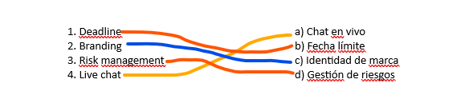

B) Fill in the Blank Complete the sentences with the correct glossary term.
1. The project _Scope__ (Alcance / Scope) defines the boundaries of what will be delivered. 2. A good _Campaing__ (Campaña / Campaign) helps promote a new product.
3. The HR team is responsible for _ Recruitment __ (Reclutamiento / Recruitment).
4. Customers often use __Live Chat_ (Chat en vivo / Live chat) to get fast support.
C) Translation Practice
Translate into Spanish:
1. The sales executive reached the monthly quota.
El salario ejecutivo llegó en la cuota mensualmente
2. The software engineer participated in a code review.
3. The HR coordinator ensured compliance with labor laws.
Translate into English:
4. El gerente de marketing analizó las tendencias del mercado.
5. El especialista de soporte al cliente realizó un seguimiento con el cliente.
D) Short Answer
Reflection 1. Why is customer satisfaction important for a company’s success?
2. How does risk management help a project manager?
3. Give an example of a digital channel you use daily.

